HISTORIC SPORTS CAR CLUB

Established 1966
Silverstone Circuit, Silverstone, TOWCESTER, Northamptonshire NN12 8TN
Telephone: +44 (0) 1327-858400 : Facsimile: +44 (0) 1327-858500
E-mail: office@hscc.org.uk : www.hscc.org.uk
Historic Sports Car Club Ltd - A company limited by guarantee - Registered in England - 04448259
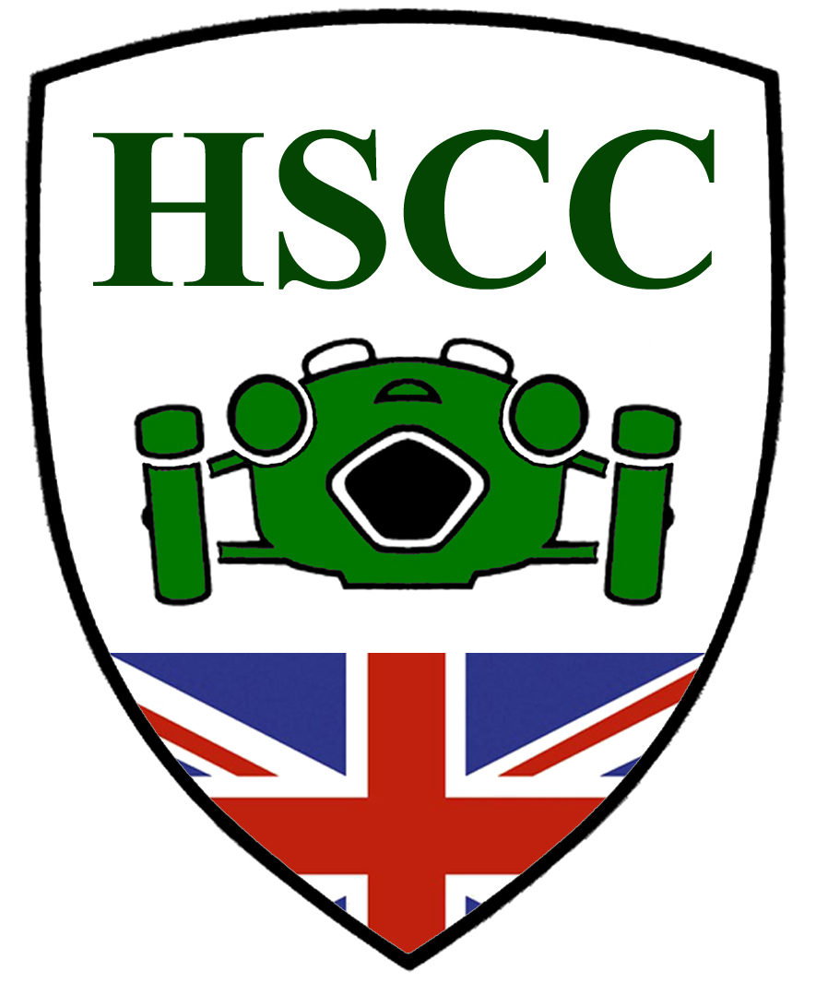

Historic Sporting Trial at Plashes Farm, near Ware, Herts

Date: 7th August 2021

Supplementary Regulations

1. The Historic Sports Car Club will organise a Clubmen’s Permit historic sporting trial at Plashes Farm, Gore Lane, Colliers End, near Ware, Hertfordshire SG11 1ES on Saturday the 7th August 2021.
2. The Meeting will be governed by the General regulations of Motorsport UK (Incorporating the provisions of the International Sporting code of the FIA), these SR’s and any written instructions the organising club may issue for the event.
3 . Motorsport UK. Permit number 120685
4. The event is open to all fully elected members of the organising club and members of the following invited clubs, BTRDA, NPTCC, 750 Motor Club, MCC, HSCC, VSCC, MAC, Stroud and District MC, Kentish Border CC, Southsea Motor Club Ltd, Woolbridge MC, Falcon Motor Club, Midlands Trials Car Club and Golden Valley HLCC.
5. All drivers and passengers must produce a valid competition licence (minimum RS Clubmans) and be a member of a registered club.
6. The event will be at Plashes Farm, Gore Lane, Colliers End, Near Ware, Hertfordshire, SG11 1ES. Public Roads will not be used to link sections. There will be 3 laps of 6 sections on private land. The entry will be split into groups starting at different hills to enable the programme to be completed.
7. Scrutineering starts at 9.30am First test: 10.30am. Any competitor who has not collected their competition number and scorecard pack by 10.15am may be excluded.
8. Awards to be presented as follows.
Best overall performance of the day: Driver and Passenger, The HSCC Historic Sporting Trial Award
Best Performance Historic Class: Driver and Passenger
Best Performance Post Historic Class: Driver and Passenger
Best performance by lady driver – subject to sufficient entries
A Special “Spirit of the day” Award to be presented at the Organisers discretion.

9. Entries opens on the publications of these SR’s.
All entries must be made using the online entry system Purple Lap.

10. The entry fee is £55.00. Payment by bank transfer to
Account: HSCC Ltd
Sort Code: 20 57 40
Account number: 83777979
Please put your name and “Trial” against your payment.
If this method of entry and payment causes a problem, please contact the Entry Taker Martyn Halliday – mobile 07739 464170 or the Secretary of the Meeting -see later.
Entries will close on 2nd August 2021. Entry fees will be refunded if the Entry Taker or Secretary of the Meeting is notified by telephone or email of a competitor’s cancellation by 12 noon on the 6th August 2021
11. The maximum entry for the meeting is 60, the minimum is 10. Should the minimum figure not be met the organisers have the right to cancel the meeting.
12. The officials are: Club Steward: TBA
Chief scrutineer: TBA;
Clerk of Course; I Wright.
Chief Marshal: TBA ;
Secretary of the Meeting: Ted Oday - mobile 07802 447022 – email: ted.oday@btinternet.com
13.Provisional results will be published as soon as possible after the event, any protests to be made in accordance with 05.1.
14.Competitors will be identified by numbers, which will be provided at the start.
15.All other GR’s of the MS.UK. apply as written.
16.No person will drive a competing car on the site except the authorised competitor.
17.All competing cars must be fitted with an effective silencer. A noise test may be carried out
18.The use of motorcycles or quad bikes on the site is restricted to authorised persons only.
19.A first Aider will be in attendance
20.Toilet facilities will be available

