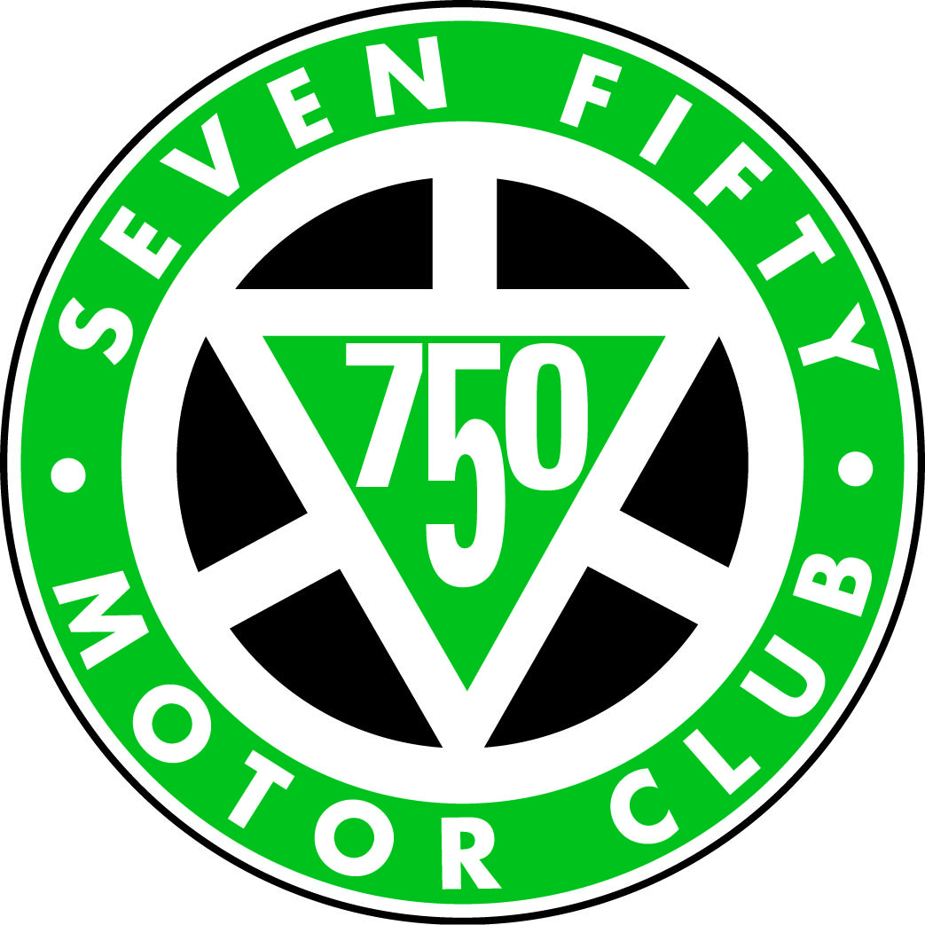
750 Historic Plum Pudding Sporting Trial
Date: MONDAY 28th December 2020
Supplementary Regulations

1. The 750 Motor Club Ltd will organise a Clubmen’s Permit historic sporting trial at Head Down, Buriton, near Petersfield, Hants, GU31 5SN on MONDAY 28th December 2020.
2. The Meeting will be governed by the General regulations of the Motorsport UK Ltd (Incorporating the provisions of the International Sporting code of the FIA), These SR’s and any written instructions the organising club may issue for the event.
3 Motorsport UK. Permit number 119296
4. The event is open to all fully elected members of the organising club and members of the following invited clubs, BTRDA, NPTCC, 750 Motor Club, MCC, HSCC, VSCC, MAC, Stroud and District MC, KBCC(Sportingtrials.com),Southsea Motor Club Ltd, Woolbridge MC, Falcon Motor Club, Dellow Register, Midlands Trials Car Club and Golden Valley HLCC..
5 The event will be at Head Down, Buriton, near Petersfield, Hants GU31 5SN. Public Roads will not be used to link sections. There will be 6 sections on private land to be attempted at least 3 times. The entry will be split into groups starting at different hills to enable the programme to be completed.
6. Scrutineering starts at 9.30am First test: 10.30am
7 Awards to be presented as follows.
Best overall performance of the day: 750 Historic Plum Pudding Sporting Trial Driver and Passenger
Best Performance Historic Class . Driver and Passenger
Best Performance Post Historic Class Driver and Passenger
A Special “Spirit of the day” Award to be presented at the Organisers discretion
8. The entry list opens on the publications of these SR’s. The entry fee is £55.00. All entries should be completed using the Purple Lap online system. Entry payments should be made to
Barclays Account name: - 750 Motor Club Trials Account
Sort Code 20-14-33
Account – 00665118
Payment date 18th December 2020
Please include your name and refence HPP20
Entries will close on FRIDAY 18th December 2020.
Entry fees will be refunded if the Entries Secretary is notified by telephone or email of a competitor’s cancellation by 12 noon on the 27th December 2020

9. The Entries Secretary is: Martyn Halliday, Goldfinch Cottage, Sedgwick Lane, Sedgwick, Horsham, West Sussex, RH13 6QE Phone 01403 250967, Mobile: 07739 464170: email: martyn_halliday@msn.com
10. The maximum entry for the meeting is 55, the minimum is 10. Should the minimum figure not be met the organisers have the right to cancel the meeting.
11. The officials are: Club Steward: TBA Chief Scrutineer: TBA; Clerk of Course; Kevin Judd; Chief Marshal TBA. Secretary of the Meeting: TBA;
12. Provisional results will be published as per D26 and full results will be emailed to competitors. Protests to be made in accordance with Section C 5.1.
13. Competitors will be identified by numbers, which will be provided at signing on.
14. All other GR’s of the Motorsport UK. apply as written. All competitors must comply with the appropriate Motorsport UK COVID-19 Guidance. For safety reasons ALL competitors, irrespective of whether they are in the same household or bubble, must wear face masks when competing. Double drives are permitted provided they remain the same crew.
15. No person will drive a competing car on the site except the authorised competitor.
16. All competing cars must be fitted with an effective silencer. A noise test may be carried out
17. The use of motorcycles or quad bikes on the site is restricted to authorised persons only.
18. A first Aider will be in attendance
19. Toilet facilities will be available
20. It is hoped there will be a food van at the event which will sell a limited menu.

